Supplementary Material B
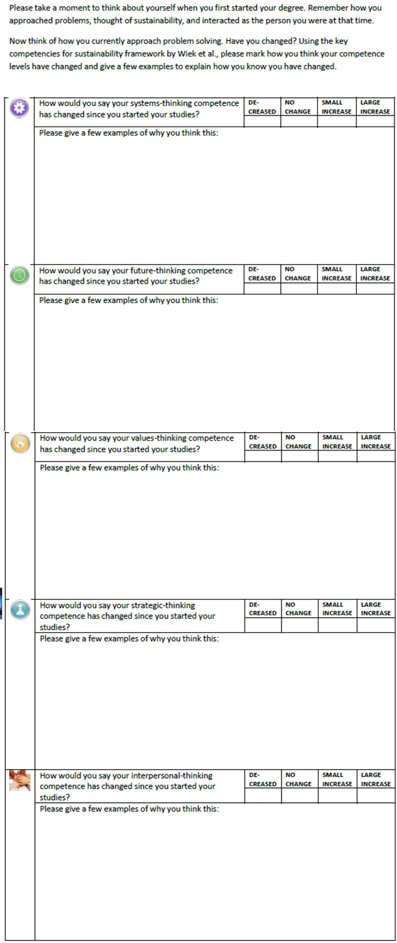
FINAL SELF-ASSESSMENT FRAME

